Name: Angad Sandhu
Registration Number: 190905494
Section: CSE-A
Roll Number: 60
Subject: DS Lab 5

1) Try the given wordcount program for heart disease dataset, covid 19 dataset, example dataset and german credit dataset
# mapper.py
import sys

for line in sys.stdin:
words = line.strip().split(',')

for word in words:
print("%s\t%d"%(word, 1))

#reduce.py
from operator import itemgetter
import sys

current_word = None
current_count = 0
word = None

for line in sys.stdin:
try:
word, count = line.strip().split('\t', 1)
count = int(count)
except ValueError:
continue

if current_word == word:
current_count += count
else:
if current_word:
print("%s\t%d"%(current_word, current_count))

current_count = count
current_word = word

if current_word == word:
print("%s\t%d"%(current_word, current_count))

Output:
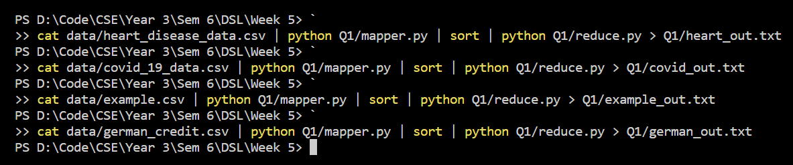
Output files (trucated)
heart_out.txt:
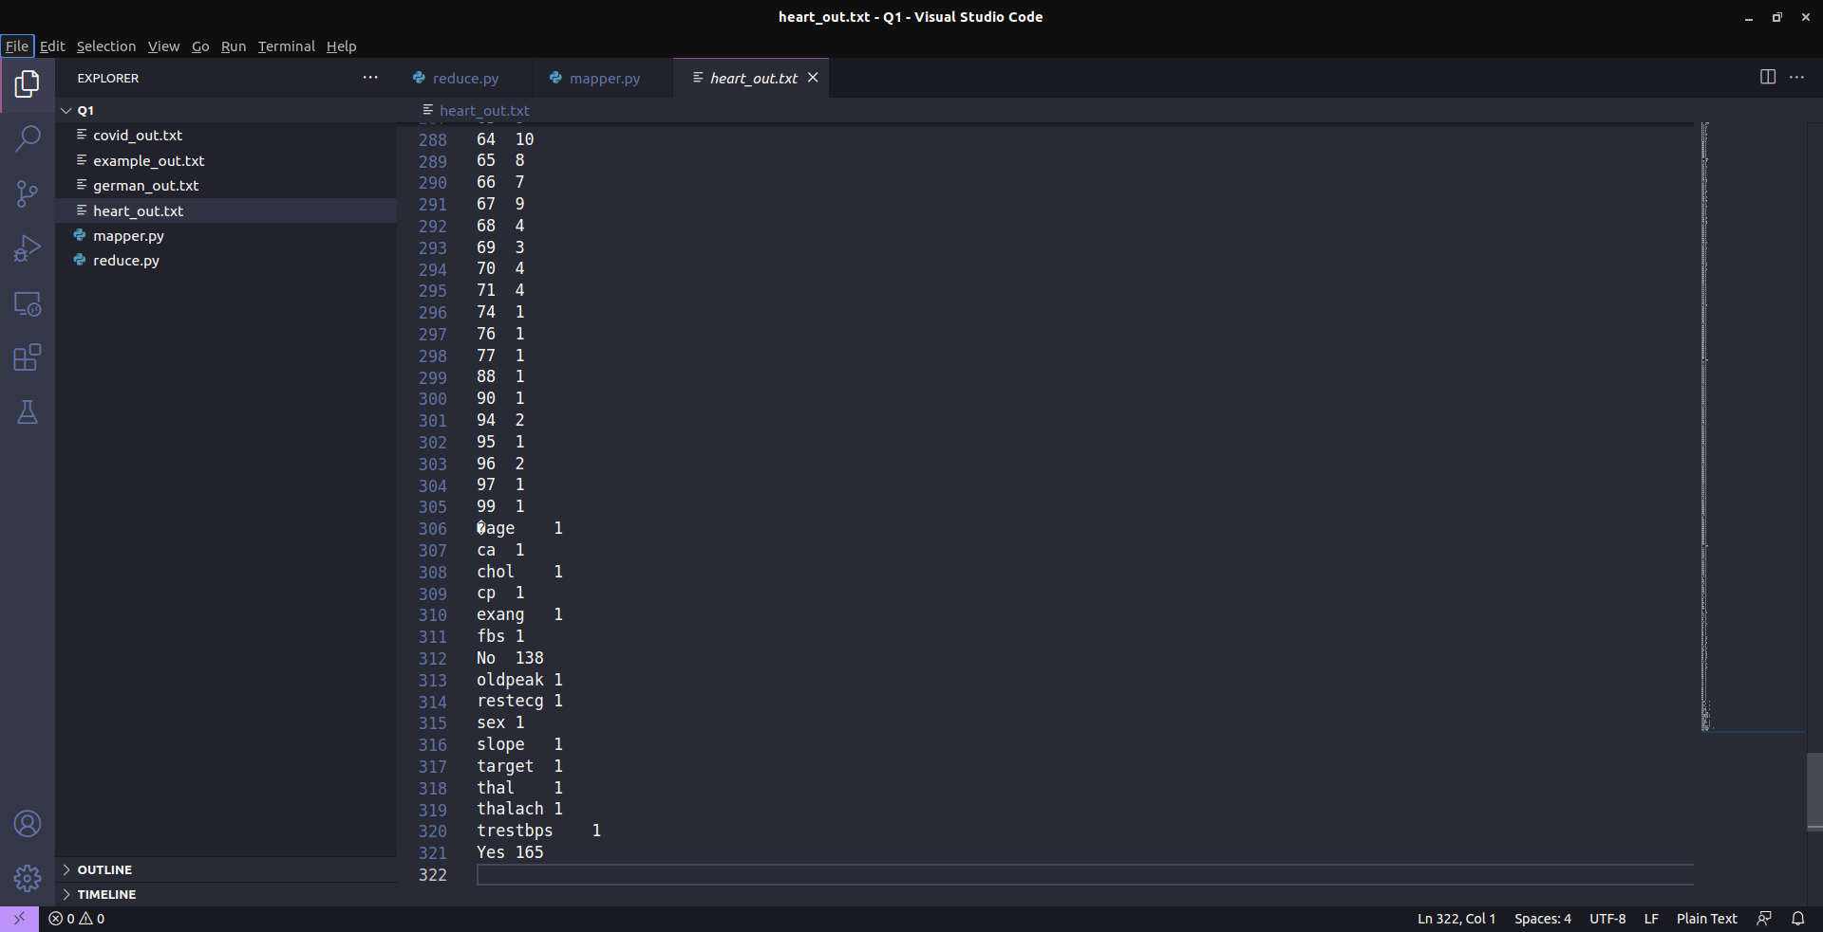
covid_out.txt:

example_out.txt:
german_out.txt:
2) Map Reduce Program to find frequent words
Try the given frequent word count program for heart disease dataset, covid 19 dataset, example dataset, and german credit dataset

#freqmap1.py:
import sys

for line in sys.stdin:
L = [ (word.strip().lower(), 1) for word in line.strip().split(',') ]

for word, n in L:
print("{}\t{}".format(word, n))

#freqred1.py
import sys

lastWord = None
sum = 0

for line in sys.stdin:
try:
word, count = line.strip().split('\t', 1)
count = int(count)
except ValueError:
continue

if lastWord == None:
lastWord = word
sum = count
continue

if word == lastWord:
sum += count

else:
print("{}\t{}".format(lastWord, sum))
sum = count
lastWord = word

# output last word
if lastWord == word:
print("{}\t{}".format(lastWord, sum))

#freqmap2.py:
import sys

for line in sys.stdin:
word, count = line.strip().split('\t', 1)
count = int(count)
print("{}\t{}".format(word, count))

#freqred2.py:
import sys

mostFreq = []
currentMax = -1

for line in sys.stdin:
word, count = line.strip().split('\t', 1)
count = int(count)

if count > currentMax:
currentMax = count
mostFreq = [ word ]

elif count == currentMax:
mostFreq.append(word)

for word in mostFreq:
print("{}\t{}".format(word, currentMax))

Output:
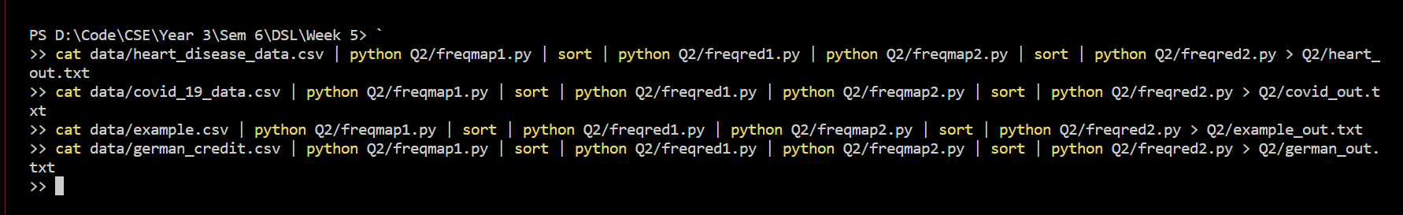

heart_out.txt:
0 1145

covid_out.txt:
0 45012

example_out.txt:
amex 13

german_out.txt:
1 700

3) MapReduce Program to explore the dataset and perform filtering (typically creating key value pairs) by mapper and perform count and summary operations on instances.

#itemmap.py (for heart disease dataset)
import fileinput

for line in fileinput.input():
data = line.strip().split(",")

if len(data) == 14:
age, sex, cp, trestbps, chol, fbs, restecg, thalach, exang, oldpeak, slope, ca, thal, target = data
print("{}\t{}".format(age, trestbps))

#itemmap.py (for covid 19 dataset)
import fileinput

for line in fileinput.input():
data = line.strip().split(",")

if len(data) == 8:
sno, observationdate, province, country, lastupdate, confirmed, deaths, recovered = data
print("{}\t{}".format(country, confirmed))

#itemmap.py (for example dataset)
import fileinput

for line in fileinput.input():
data = line.strip().split(",")

if len(data) == 6:
date, time, location, itemtype, amount, cardtype = data
print("{}\t{}".format(itemtype, amount))

#itemmap.py (for german credit dataset)
import fileinput

for line in fileinput.input():
data = line.strip().split(",")

if len(data) == 3:
credibility, creditamount, durationofcredit = data
print("{}\t{}".format(credibility, creditamount))

#itemred.py:
import fileinput

transaction_count = 0
sales_total = 0

for line in fileinput.input():

try:
data = line.strip().split("\t")
if len(data) != 2:
continue
except ValueError:
continue

current_key, current_value = data
try:
sales_total += float(current_value)
transaction_count += 1
except ValueError:
continue

print("{}\t{}".format(transaction_count, sales_total))

Output:

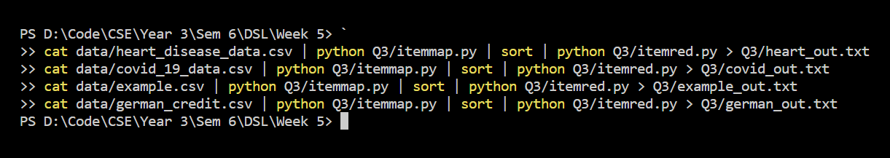

4) Write a mapper and reducer program for word count by defining a seprator instead of using “\t”
#sepmap.py
import sys

def read_input(file):
for line in file:
yield line.strip().split(',')

def main(separator="\t"):
data = read_input(sys.stdin)
for words in data:
for word in words:
print("%s%s%d"%(word, separator, 1))

if __name__ == '__main__':
sep = sys.argv[1]
main(separator=sep)

#sepred.py:
import sys
from itertools import groupby
from operator import itemgetter

def read_mapper_output(file, separator='\t'):
for line in file:
yield line.rstrip().split(separator, 1)

def main(separator="\t"):
data = read_mapper_output(sys.stdin, separator=separator)
for current_word, group in groupby(data, itemgetter(0)):
try:
total_count = sum(int(count) for current_word, count in group)
print("%s%s%d"%(current_word, separator, total_count))
except ValueError:
pass

if __name__ == '__main__':
sep = sys.argv[1]
main(separator=sep)

Output:

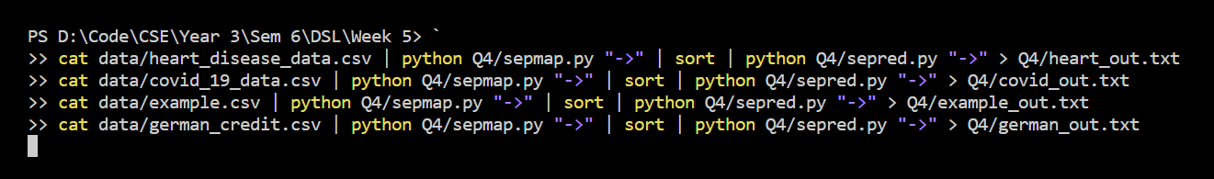

Output files (truncated):
heart_out.txt:
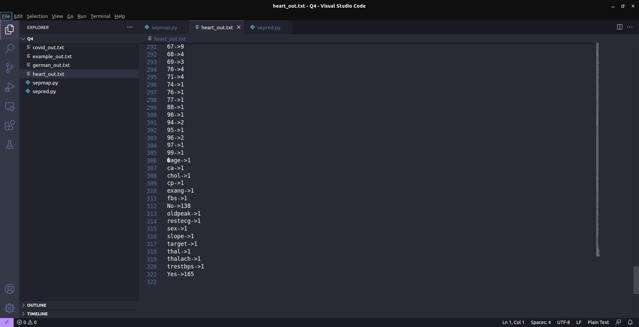
covid_out.txt:
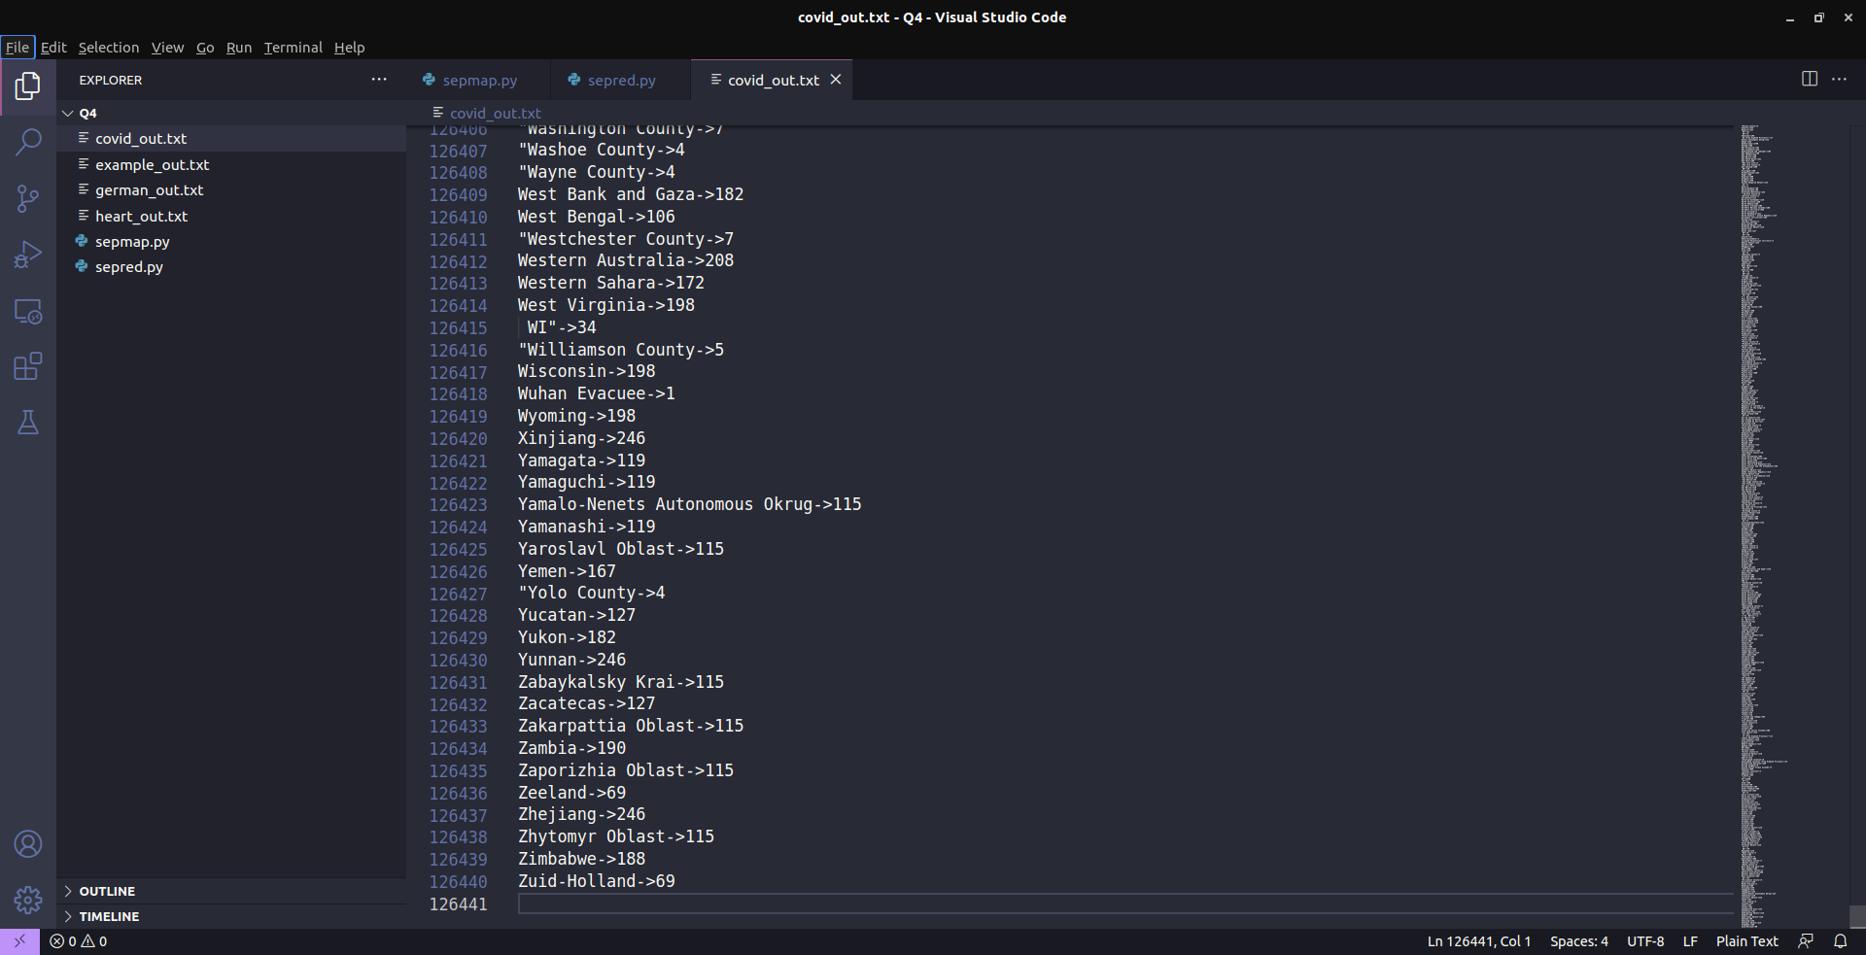

example_out.txt:
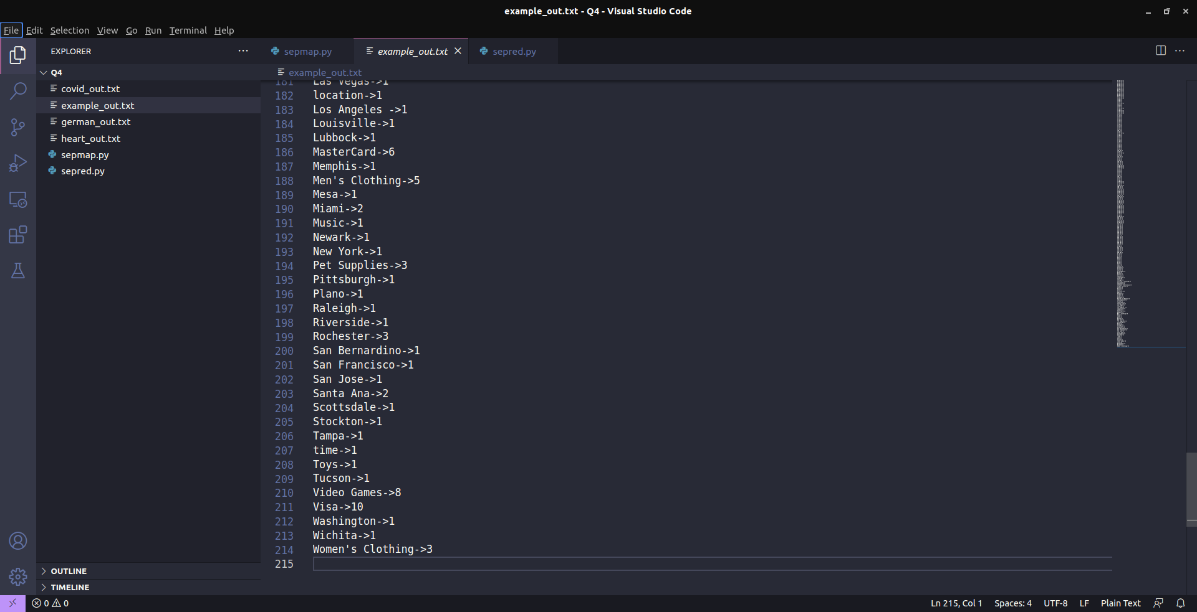
german_out.txt:

5) Try to apply finding max value using map redeuce concept for the output of heart disease dataset, covid 19 dataset, example dataset, german credit dataset

#costmap.py (for heart disease dataset):
import fileinput

for line in fileinput.input():
data = line.strip().split(",")

if len(data) == 14:
age, sex, cp, trestbps, chol, fbs, restecg, thalach, exang, oldpeak, slope, ca, thal, target = data
print("{}\t{}".format(sex, chol))

#costmap.py (for covid 19 dataset):
import fileinput

for line in fileinput.input():
data = line.strip().split(",")

if len(data) == 8:
sno, observationdate, province, country, lastupdate, confirmed, deaths, recovered = data
print("{}\t{}".format(observationdate, confirmed))

#costmap.py (for example dataset)
import fileinput

for line in fileinput.input():
data = line.strip().split(",")

if len(data) == 6:
date, time, location, itemtype, amount, cardtype = data
print("{}\t{}".format(itemtype, amount))

#costmap.py (for german credit dataset)
import fileinput

for line in fileinput.input():
data = line.strip().split(",")

if len(data) == 3:
credibility, creditamount, durationofcredit = data
print("{}\t{}".format(credibility, creditamount))

#costred.py:
import fileinput

max_val = 0
old_key = None

for line in fileinput.input():

data = line.strip().split("\t")

if len(data) != 2:
continue

current_key, current_value = data
try:
v = float(current_value)
except ValueError:
continue

if old_key and (old_key != current_key):
print("{}\t{}".format(old_key, max_val))
old_key = current_key

max_val = 0

old_key = current_key
if float(current_value) > float(max_val):
max_val = float(current_value)

if old_key != None:
print("{}\t{}".format(old_key, max_val))

Output:
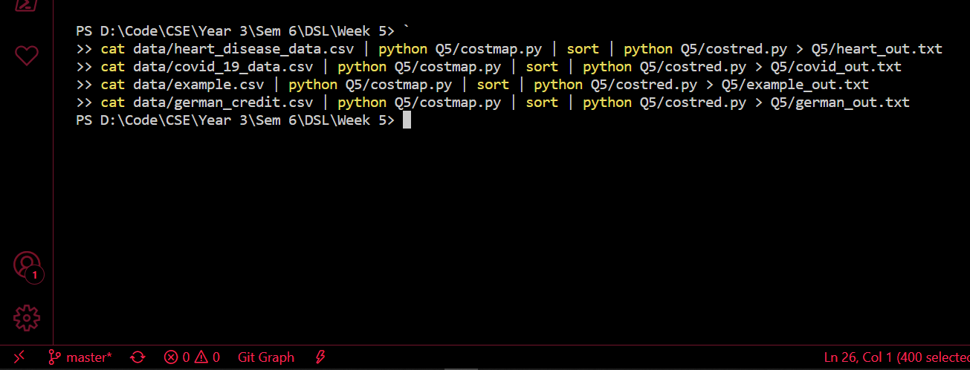

Heart_out.txt example_out.txt
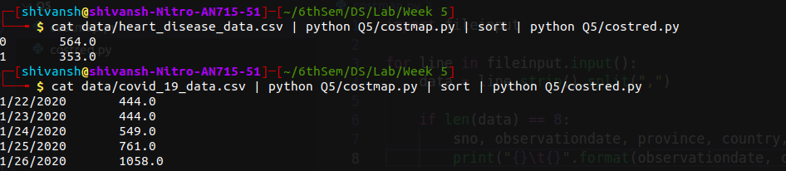
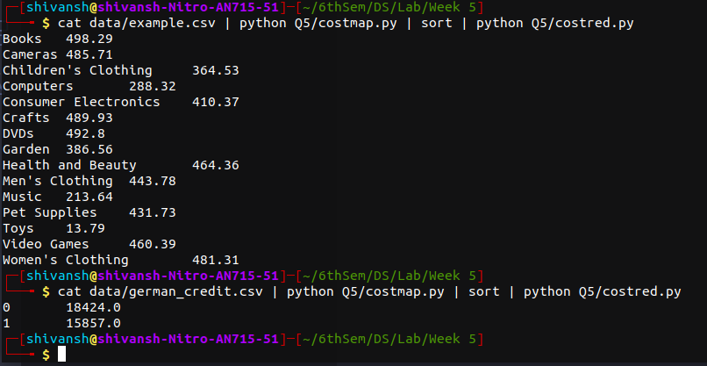

covid_out.txt

German_out.txt

6) (Instructed to not do)
7) Write a map reduce program to count even or odd numbers in randomly generated natural numbers

#mapper.py:
import sys

for line in sys.stdin:
words = line.strip().split()

for word in words:
num = int(word)
if num % 2 == 0:
print("%s\t%d"%("even", 1))
else:
print("%s\t%d"%("odd", 1))

#reduce.py
from operator import itemgetter
import sys

current_word = None
current_count = 0
word = None

for line in sys.stdin:
try:
word, count = line.strip().split('\t', 1)
count = int(count)
except ValueError:
continue

if current_word == word:
current_count += count
else:
if current_word:
print("%s\t%d"%(current_word, current_count))

current_count = count
current_word = word

if current_word == word:
print("%s\t%d"%(current_word, current_count))

Output:
